Name: K.Poorna chandu
Reg No: 192312585
Subject: ECA56 –5G / 6G Communication Systems

Experiment 4: OFDMA Resource Block Allocation
Aim: To simulate and analyze OFDMA (Orthogonal Frequency Division Multiple Access)
resource block allocation and evaluate system performance in terms of resource utilization and user throughput using MATLAB.
Objective 1:
clc; clear; close all;
% System parameters
bandwidth = 10e6; % 10 MHz
rb_size = 180e3; % 180 kHz per RB
% Total Resource Blocks
total_RB = floor(bandwidth / rb_size);
% Users
users = 1:6;
% RB allocation (simple equal + remainder distribution)
base = floor(total_RB / length(users));
alloc = base * ones(1,length(users));
alloc(1:mod(total_RB,length(users))) = alloc(1:mod(total_RB,length(users))) + 1;
utilization = (alloc / total_RB) * 100;
disp('Total Resource Blocks:')
disp(total_RB)
disp('RB Allocation per User:')
disp(alloc)
figure
% -------- Graph 1: RB Allocation per User --------
subplot(2,1,1)
stem(users, alloc, 'filled', 'LineWidth', 2)
title('OFDMA Resource Block Allocation per User')
xlabel('User Index')
ylabel('Number of Resource Blocks')
grid on
% -------- Graph 2: RB Utilization --------
subplot(2,1,2)
plot(users, utilization, '-o', 'LineWidth', 2)
title('OFDMA Resource Block Utilization (%)')
xlabel('User Index')
ylabel('Utilization (%)')
grid on
Output:
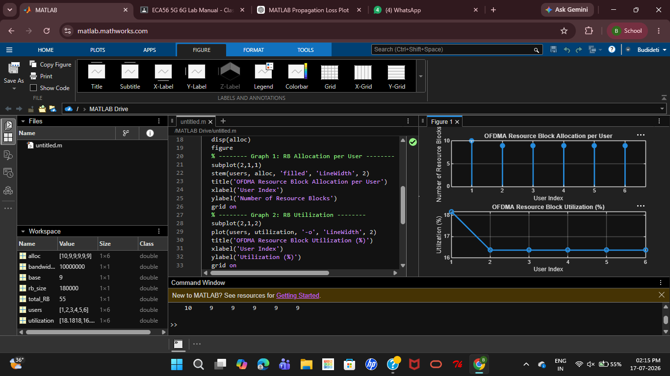

Objective 2:
MATLAB Code:
clc; clear; close all;
% Total system resource blocks
total_RB = 50;
% Number of active users
users = 1:5;
% RB allocation to users (example scenario)
alloc = [12 10 9 8 11];
% Resource Block Utilization (%)
util = (alloc / total_RB) * 100;
disp('Resource Block Utilization (%) per User:')
disp(util')
figure
% -------- Graph 1: RB Allocation --------
subplot(2,1,1)
plot(users, alloc, '-o', 'LineWidth', 2)
title('OFDMA Resource Block Allocation per User')
xlabel('User Index')
ylabel('Number of Resource Blocks')
grid on
% -------- Graph 2: Utilization (%) --------
subplot(2,1,2)
plot(users, util, '-s', 'LineWidth', 2)
title('OFDMA Resource Block Utilization (%)')
xlabel('User Index')
ylabel('Utilization (%)')
grid on

Output:
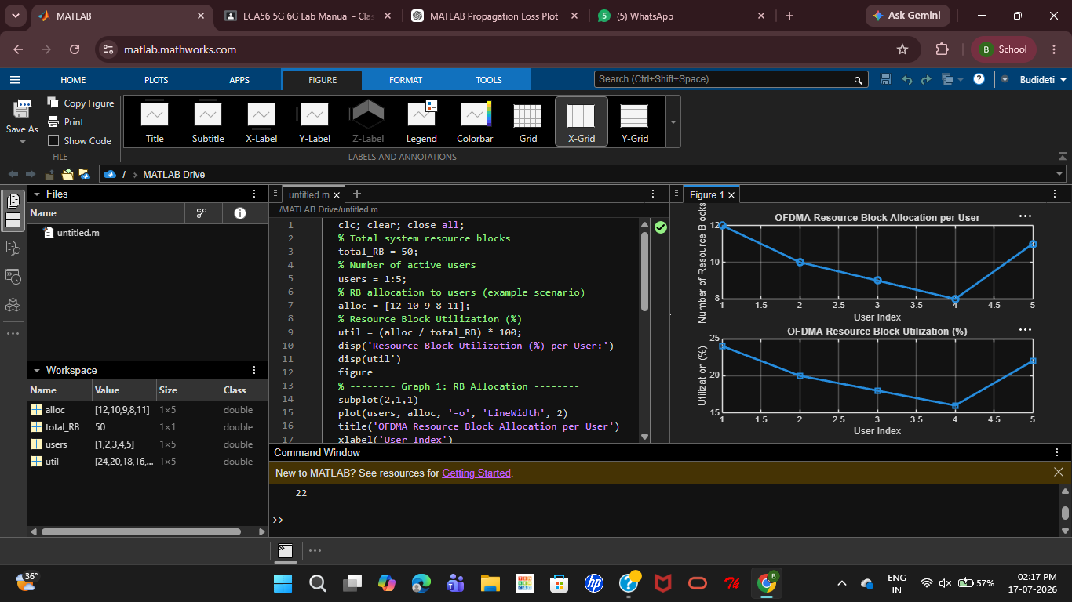
Objective 3:
MATLAB Code:
clc; clear; close all;
% System parameters
rb_bw = 180e3; % Bandwidth per RB (180 kHz)
users = 1:5;
% Allocated Resource Blocks per user
alloc_RB = [12 10 9 8 11];
% Modulation efficiency (bits/symbol)
mod_eff = [2 4 6 4 2]; % QPSK, 16QAM, 64QAM etc.
% Throughput calculation (Mbps)
throughput = (alloc_RB .* rb_bw .* mod_eff) / 1e6;
disp('User Throughput (Mbps):')
disp(throughput')
figure
% -------- Graph 1: Throughput per User --------
subplot(2,1,1)
plot(users, throughput, '-o', 'LineWidth', 2)
title('OFDMA User Throughput')
xlabel('User Index')
ylabel('Throughput (Mbps)')
grid on
% -------- Graph 2: RB vs Throughput --------
subplot(2,1,2)
plot(alloc_RB, throughput, '-s', 'LineWidth', 2)
title('Resource Blocks vs Throughput Relationship')
xlabel('Allocated Resource Blocks')
ylabel('Throughput (Mbps)')
grid on
Output:
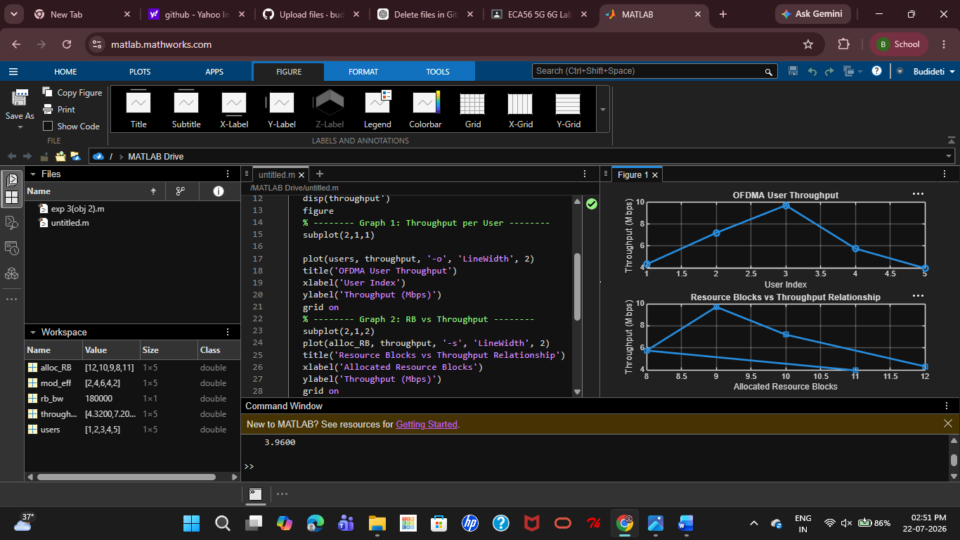
Result:The propagation loss for Sub-1 GHz, Mid-band, and mm Wave frequency bands was successfully analysed using MATLAB. The results showed that propagation loss increases with both frequency and communication distance, with mm Wave experiencing the highest attenuation and Sub-1 GHz providing the best coverage.

